To generate UML diagram classes of the project, in Android Studio,

Download plugins “Plant UML parser” and “PlantUML integration”

Follow the integrated tutorial to generate UML with “Plant UML parser”.

If you want to export the diagram in JPG, open on the right side of the screen, the “PlantUML integration” interface. It should open the generated UML diagram.

Then on the top, click on the save icon to export it in JPG

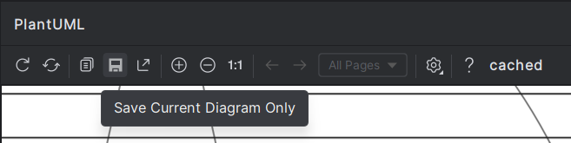

Then save it.